**Cookies object**

Setting and data about the user are stored in small text files, on your computer these stored data called “Cookies”; it was invented to solve the problem of “how to remember information about the user".

**Example:**

* When a user visits a web page, his/her name can be stored in a cookie.
* Next time the user visits the page, the cookie "remembers" his/her name.

Cookies are saved in name-value pairs. And if you want to create, modify, or delete cookies you must use **document.cookie** property.

1. **Create cookie syntax: document.cookie = “name = content; expires = future-date; path =/”**

The above syntax is consisting of three parts:

1. **name = content 🡺** Determine user’s data that will be stored (required).
2. **expires = date 🡺**Determine expiry date (in UTC time) of this data. By default, the cookie is deleted when the browser is closed (**optional**).
3. **Path = / 🡺** with path parameter you can tell the browser what path the cookie belongs to. By default, the cookie belongs to the current page (**optional**).
4. **Modify cookie syntax: document.cookie = “name = new-content; expires =new- future-date; path =/”**

**Note:** modification data will be stored in the same cookie, but if you modify the path parameter modification data will be stored in a new cookie. {Old and new cookie will beExisted}

1. **Delete cookie syntax: document.cookie = “name ; expires = past-date; path =/”**

**Note:**

* Content of cookie is optional when deleting it.
* Path is required when deleting cookie as it tell the browser which cookie should be deleted.
* Path is optional **only** if the cookie has **no path** (by default current page).

**Examples:**

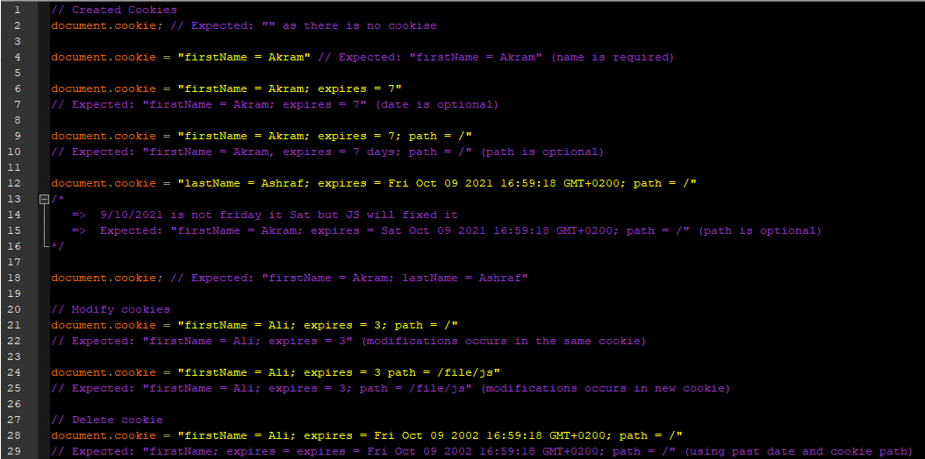

**Note:** You can display cookies from the setting of your browsers.

Use this link for more cookies: <https://github.com/js-cookie/js-cookie>